**Infantry Supply Station Design for DJI RoboMasters Competition**

BY:

Rahmat Saeedi, Xinru Song, YiFeng Wang, & Yuyong Yao

Electrical and Computer Engineering, University of Alberta,

116 Street and 85 Avenue, Edmonton, AB, Canada T6G 2R3

(Group #: 9)

FOR:

**University of Alberta RoboMasters Student Group**

Vincent Zhou & Terry Hong

ECE Student Groups

University of Alberta

116 Street and 85 Avenue, Edmonton, AB, Canada T6G 2R3

Contents

Introduction & Motivation 2

RoboMasters Permitted Refueling Methods 3

Project Black Box Diagram 5

Regulatory Information 6

Budget 6

Objectives Pairwise Comparison Chart 7

User Interface 7

Operation Description 8

A Sketch of the Supply Station 8

Tables and Figures 9

# Introduction & Motivation

DJI RoboMasters competition, is an annual robotics competition for postsecondary students across the globe that is intended to offer a platform to promote exchange and dialog among researcher and students alike. This global tournament is sponsored by SZ DJI Technology Co. LTD, and hosted by Communist Youth League of China, Secretariat of All-China Students’ Federation, and Shenzhen Municipal Government. To promote a fair and balanced competition platform, a set of annually updated competition rules are provided by the organizers of the contest, i.e. Technology Innovation Committee of Nanshan District Government of Shenzhen Municipality. The competition uses a range of robots, including Aerial, Base, Hero, Standard, and Engineering robots, each of which must satisfy a certain set of requirements. During the competition robots are able to fire bullets of standardized size at a Referee System attached to the sides of robots. Robots are equipped by HD cameras and are controlled wirelessly from another control room. Robots are able to refuel their ammunition anytime during the game at a stationary Supply Station that collects limited bullets distributed to teams at fixed intervals during the game. In total, eight hundred bullets of 2.6 g (±5%), plastic (TPE 90), of diameter 17 mm (-3% to 0%) are released in total during the game; 200 bullets initially, 300 bullets at 2 minutes 30 seconds mark, and 300 bullets at 5 minutes mark. A Base robot may also be refueled by an Engineering or Hero robots, while the Hero robot may be also refueled by Engineering or Arial robots. Engineering robot collects ammunition from the battle ground while Aerial robot gathers ammo from a resource column, tarmac, Hero, or Engineering robot.

University of Alberta’s RoboMasters Student group competed for the first time in 2017 and is planning to compete again in 2018. Previously, they used a mechanically-triggered supply station that was activated while a robot was pushing a mechanical lever. The supply station lacked the control needed to refill robots with accuracy and speed. The team needs to redesign the station to allow for accurate loading of about 50 bullets at a fast pace, while ensuring no bullets gets jammed in the supply station. Various robots are allowed to refuel at the supply station, see table 1, but the team is planning to use the supply station only to refuel 3 infantry robots. The supply station needs to confirm with the RoboMasters organizing committees’ mandated rules. Moreover, the team needs the station to autodetect, auto release ammunition, and refuel two infantry robots simultaneously. A team of mechanical engineering students are designing 3 infantry robots that would be using this supply station. Clear communication with this team would be necessary throughout the year to ensure that the supply station would be fit for use by the infantry robots. Specifically, for our design, we need to know the shape, location, dimensions of robots’ ammunition container. The client’s main goals and constrains could be summarized as follows:

1. Conforms with DJI RoboMasters’ competition rules,
2. Safe to use,
3. Fast ammunition loading rate; the faster the better,
4. Absolutely no jamming of bullets in the station,
5. Fully automatic,
6. Able to refuel two robots simultaneously,
7. Can be easily setup and carried by two personnel,

# RoboMasters Permitted Refueling Methods

The table below shows the officially permitted refueling mechanisms. The client requires only the Standard Infantry Robot to be able to use the supply station. Non-the-less, for information purposes, presented are the DJI regulations.

**Table 1:** DJI RoboMasters allowed robots and refueling mechanism. University of Alberta team is planning to use refueling station only for Standard Infantry Robots.

|  |  |  |  |
| --- | --- | --- | --- |
| Robot | Quantity | Function | Bullet Supply Method |
| Base Robot | 1 | Automatic Self-Defense Robot | >Initial 300 bullet |
| Hero Robot | 1 | Has high offensive power | >Refueling Station  >Engineering Robot  >Resource Island  >Aerial Robot |
| Engineering Robot | 0-1 | Assistant Robot, heals and gathering ammo from battle field | >Tarmac  >Resource Island  >Aerial Robot |
| Standard Infantry Robot | 0-3 | Fight flexibility | >Refueling Station  >Engineering Robot  >Resource Island  >Hero Robot |
| Aerial Robot | 0-1 | Supplies aerial support, may help in refueling, and may occupy healing columns | >Tarmac  >Resource Column  >Engineering Robot  >Hero Robot |
| Refueling Station | 0-1 | Ammunition supply station, collects ammunition, and automatically dispenses ammunition | >Official Supply Mechanism |

Scope of specification

The supply station shall be placed in the refueling area and completely automatic to provide 17 mm ammo to infantry robots during the competition. There will be no limits for its ammo quantity. The supply station will be emptied before a game starts. After a game starts, the official refueling mechanism will release 200 bullets (17 mm in diameter) and another batch of 300 bullets will be released after 2 minutes 30 seconds into a game. After 5 minutes into a game, another batch of 300 bullets will be released. DJI RoboMasters require the station to be satisfy the following constrains:

1. be fully automatic,
2. can handle 17 mm in diameter ammunition,
3. The size of the supply station should not exceed 1000*1000*1000mm;
4. Any active movement or firing mechanism are not allowed;
5. No need for referee system during the competition.
6. self-balancing; i.e. cannot be fixed to the ground using tape or materials that can damage the competition area,
7. has a maximum supply voltage of 30 volts, and maximum total power of 200 Wh
8. if radio communication is employed, a bandwidth of less than 40 MHz within 2.412 to 2.472 GHz is used,

The supply station we designed for University of Alberta RoboMasters Student Group are able to store ammo provided by RoboMasters host, distributes around 50 bullets each to two infantry robots simultaneously within 5 seconds. In order to achieve the above goals, a container for storing bullets on the top, and a mechanism to smoothly guide and release the is essential. Moreover, several revolving storages may be required to save time during transmitting bullets to robots. The supply station should be controlled automatically, thus sensors for detecting the docking of the infantry robots are required. When robots reach the specific area under the supply station, the refueling station will distribute the bullets to the robots immediately. A switch and battery are also necessary for supply station.

# Project Black Box Diagram

Presented below is the black-box diagram that presents the input and output of the

* **Docking Signal**: The signal for the docking of the infantry robots
* **Ammunition**:

The bullets distributed by the RoboMasters Official Supply Mechanism during the game

* **Power** from the battery
* **Adjustments** in the height of the dumping opening that dispenses bullets into the infantry robots
* DJI RoboMasters **competition regulations**

* **Distributes about fifty bullets** each to two infantry robots simultaneously
* Able to automatically sort out about fifty bullets and store them in a batch in the individual storage unit that is ready to fill the robots at anytime after receiving docking signal at the dumping sites.
* Able to **store bullets** that are distributed by the RoboMasters during the game

Project:

Infantry Robots Supply Station

# Regulatory Information

There are not many known regulations that govern robots designed for such competition, research, and educational purposes. Since the end product would not be connected to external electrical outlets, and since the product would not be equipped with wireless communications, and additionally it would not fall under consumer product category, thus we believe common safety rule should be followed.

**Table 2:** Projects function, specification, and regulatory information is presented below.

|  |  |  |
| --- | --- | --- |
| Project Function | Specification | Regulatory Information |
| Able to compete in DJI RoboMasters competition | * Will be presented as the Refueling Supply Station Robot | * RoboMasters Competition Rules Version 1.9 (2017.6) or its later updates |
| Automatic & Robotic Behavior | * Ethical principles for designers of robots | * Isaac Asimov’s Laws of Robotics * Engineering and Physical Sciences Research Council’s Principles of Robotics |
| Controlling motors and switches | * Microcontroller, * Controls all the motors, possibly electromagnets, load cell and sensors | * IEEE 802.3 |
| Battery | * Support all the electronic device on the station * Max supply power: 200Wh |  |
| To open /close ammunitions supply gates | * Motor/Electromagnets * Satisfy overall size limit |  |
| Robot Docking Detection | * Sensors (laser/…) * Satisfy overall size limit |  |
| Bullets used by the robot | * Plastic (TPE 90) * Size: 17 mm (-3% - 0%) * Weight: 2.6 g (±5%) |  |
| Refueling Station | * Maximum Size: 1000*1000*1000mm |  |

# Budget

The budget limit for this project is the $400/group that is provided by the university. The client is willing to share any possible resources that they may have access to. The client expressed that they would see if they could provide access to Mechanical Engineering 3D printer through their connection with Mechanical Engineering group responsible for structural design of the robot. The client has no objection to going over the budget, but would not be reimbursing the group for those costs.

# Objectives Pairwise Comparison Chart

Please note that the bullets that the supply station carries are plastic(TPE90) bullets that are 17mm (-3% - 0%) in diameter and weigh 2.6g (±5%). The level of importance of an objective is based on the total score that each goal is obtained from the pairwise comparison table, see table 3. Based on the analysis of pairwise comparison table, the ability to detect docking of infantry robots has the highest score and therefore is the most critical objective. While the goal of tracking the number of bullets in the refueling station has the lowest score and is the least critical objective. This analysis is logically correct, since the supply station cannot distribute bullets if it can’t detect the docking of an infantry robots. This will result in the whole project to be a failure. From the pairwise comparison table, the speed of refueling and efficiency are the next critical objectives. During the meeting with the RoboMasters representative, the client emphasized a lot on the speed and the ability to refuel two infantry stations simultaneously. Therefore, the design of the supply station needs to optimize for speed, ability to detect docking, and to refuel two infantry robots simultaneously.

The stretched goals of this project include: the ability to be maintained and carried by two people, a power management mechanism to prolong battery life, a tracking system to record the number of bullets in the refueling station, a way to avoid the supply station to become overfilled, and to make the supply station vertically adjustable. The followings are logics that justify the stretched goals. Since each game takes about seven minutes and there is a thirty second preparation time before start of each game, thus the supply station’s power source can be easily changed. But user experience would be improved if battery life is maximized. The client wants to be able to carry the station using no more than two people to since their team have thirty second preparation time before each game. A mechanism to prevent overfilling of the supply station and vertical adjustability of the supply station are not an issue for the client, since robots have a fixed heights and the number of bullets distributed to each team are limited.

From the correlation matrix, see table 4, the three objectives i) the speed to refuel, ii) the ability to refuel two robots simultaneously, and iii) the ability to dispense about 50 bullets per refuel, are highly correlated. All these objectives are highly positively related to refueling efficiency, which the client has extremely emphasized on. The ability to be handled by two people during the preparation of each game is moderately negatively correlated to all. Therefore, the ability to be handled by two people is a stretched goal.

# User Interface

Since the supply station is self-powered and, therefore the user possibly needs to turn on a switch during the preparation time before each game. After finishing the match, the user would turn off the machine. The user should also be able to easily (without need for screw driver and under 10 seconds) change the battery.

From the perspective of the infantry robots, which are the recipients for, the infantry robots are first docked at a dumping sites, and thus such location should be easily accessible to the robot. After the docking, sensors attached to the station will detect the infantry robots, hence, it would be necessary to have lasers that would not negatively interfere with the robots’ operations. The bullets are automatically distributed into the infantry robots’ top, hence, a good fit between the robot and supply station would be necessary. See image for the final project sketch.

# Operation Description

Before the competition starts, the supply station must be emptied. During the 30 seconds preparation time, two personnel should be able to set up the supply station in the refueling area. The refueling station will be turned on by a switch. After a game starts, the RoboMasters host will initially release 200 bullets (17mm in diameter) and these bullets will be stored in the main upper cylindrical-shaped storage. The refueling station will then be able to automatically distribute these bullets into batches of 50 bullets to each of the revolving storage unit on the second level until all revolving units are filled. After reaching the bullets dumping zones, the infantry robots will be detected by sensors placed on the refueling station. After detecting the successful docking, the refueling station will distribute 50 bullets to infantry robot. There will be two docking sites so that two infantry robots can be loaded at the same time. The refueling station will contain a motor under the bottom of the main cylindrical-shaped storage. This motor will run at a constant speed so that the bullets fall into the second level fast and smoothly. There will be a mechanism that will automatically distribute fifty bullets into each of the revolving storage units in the second level. Each filled-storage unit will have 50 bullets. After filling all the revolving storage units with bullets, a signal will be sent to the controller of the refueling station and the openings on the bottom of the main storage will be shut and the motor in the main storage will also stop spinning. After emptying all bullets from a revolving storage unit to an infantry robot, a signal will trigger the motor and that revolving storage unit will be placed under the opening of the main storage so that all the revolving storage units will be filled automatically and will be ready to refuel the infantry robots at any time.

# A Sketch of the Supply Station

(see attached page)

# Tables and Figures

**Table 3: Pairwise Objective Comparison Chart**

**Legend for Pairwise Objective Comparison Table**

1 indicate the row element is more important

0 indicate the row element is less important

- indicate the row element and the column element are the same

|  |  |  |  |  |
| --- | --- | --- | --- | --- |
|  | Speed of Refueling | Can fill two robots simultaneously | Can fill robots with ~50 bullets per refueling cycle | Can be maintained & carried by two people |
| Speed of Refueling | - | 0 | 0 | 0 |
| Can fill two robots simultaneously | 1 | - | 0 | 0 |
| Can fill robots with ~50 bullets per refueling cycle | 1 | 1 | - | 0 |
| Can be maintained & carried by two people | 1 | 1 | 1 | - |
| Power Source last for 30 minutes | 1 | 1 | 1 | 1 |
| Able to detect the docking of robots | 0 | 0 | 0 | 0 |
| Keep track of the # of bullets in the refueling station | 1 | 1 | 1 | 1 |
| A way to avoid the supply station being overfilled | 1 | 1 | 1 | 1 |
| The supply station is vertically adjustable | 1 | 1 | 1 | 1 |
| Total Score | 7 | 6 | 5 | 4 |

|  |  |  |  |  |  |
| --- | --- | --- | --- | --- | --- |
|  | Power Source lasts 30 minutes | Can detect docking of robots | Keeps track of the # of bullets in refueling station | Can avoid the supply station being overfilled | The supply station is vertically adjustable |
| Speed of Refueling | 0 | 1 | 0 | 0 | 0 |
| Able to fill two robots simultaneously | 0 | 1 | 0 | 0 | 0 |
| Able to fill robots with ~50 bullets during each refueling cycle | 0 | 1 | 0 | 0 | 0 |
| Able to be maintained & be carried by two members from the team | 0 | 1 | 0 | 0 | 0 |
| Power Source to lasts for 30 minutes | - | 1 | 0 | 0 | 0 |
| Can detect docking of robots | 0 | - | 0 | 0 | 0 |
| Keeps track of the # of bullets in the refueling station | 1 | 1 | - | 1 | 1 |
| Can avoid overfilling of the supply station | 1 | 1 | 0 | - | 1 |
| The supply station can be adjustable vertically | 1 | 1 | 0 | 0 | - |
| Total Score | 3 | 8 | 0 | 1 | 2 |

**Table 4: The Correlation Matrix with Design Objectives**

**Legend for the Pairwise Comparison Chart:**

++ Highly correlated positive

+ Moderately correlated positive

- Moderately correlated negative

-- Highly correlated negative

|  |  |  |  |  |  |  |  |  |
| --- | --- | --- | --- | --- | --- | --- | --- | --- |
|  | Can refuel two robots | Dispenses ~50 bullets per refuel | Can be handled by two people | Battery lasts 30 minutes | Can detect docking robots | Tracks the number of bullets | Avoids overfilling of the supply station | Supply station can be adjusted vertically |
| Speed of Refuel | ++ | ++ | - | + | + | + | + | + |
| Can refuel two robots |  | ++ | - | + | + | + | + | + |
| Dispenses ~50 bullets per refuel |  |  | - | + | + | ++ | ++ | + |
| Can be handled by two people |  |  |  | - | -- | -- | -- | ++ |
| Battery lasts 30 minutes |  |  |  |  | + | + | + | + |
| Can detect docking robots |  |  |  |  |  | - | - | + |
| Tracks the number of bullets |  |  |  |  |  |  | ++ | + |
| Avoids overfilling of the supply station |  |  |  |  |  |  |  | - |
| Supply station can be adjusted vertically |  |  |  |  |  |  |  |  |

# Figures

The overview of supply station:

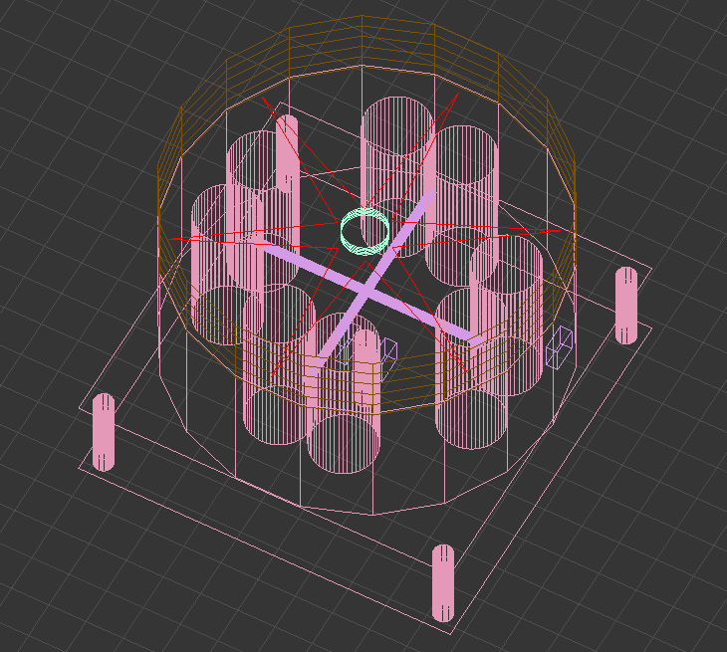

The top view of the supply station:

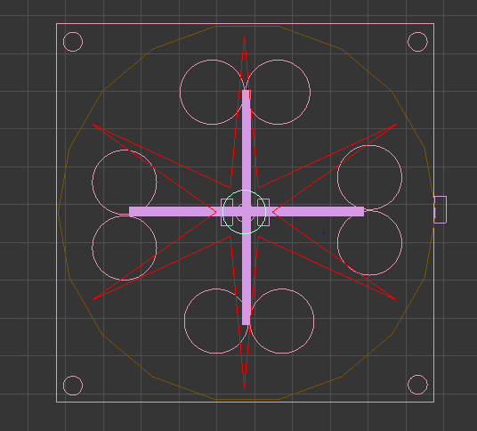

The first stage of the supply station:

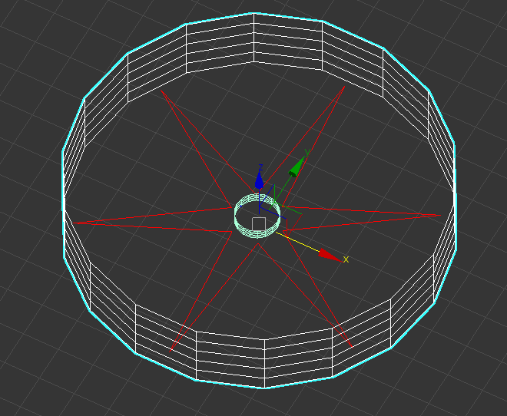

The second stage of the supply station:

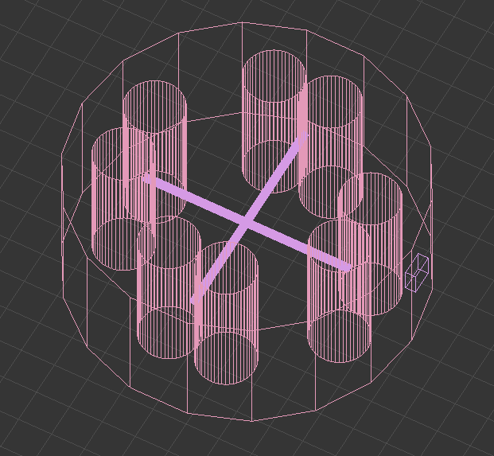

The third stage of the supply station:

